For Commerical Operators and Flight Training Facilites
Simfly can custom build a CASA Approved Aircraft Synthetic Trainer that has a full size instrument panel and flight controls with external visual projection.
- Ability to be approved under CASA CAO 45.0 (Category A, B or C, FSD-2 level synthetic flight trainer.
- Trainer for instrument flight procedures
- Trainer for cross country instrument flight navigation
- Instrument approach training and recency (including GNSS NPA)
- Logging of instrument flight time and recency
Purchase or leasing options available to approved applicants.

Cessna 172 Flight Simulator is as real as it gets as it is almost identical to the real aircraft. The Cessna 172 simulator combined with a 180 degree wrap around external visual projection makes this the perfect visual and instrument trainer to allow students to develop their required skills before entering the real aircraft.

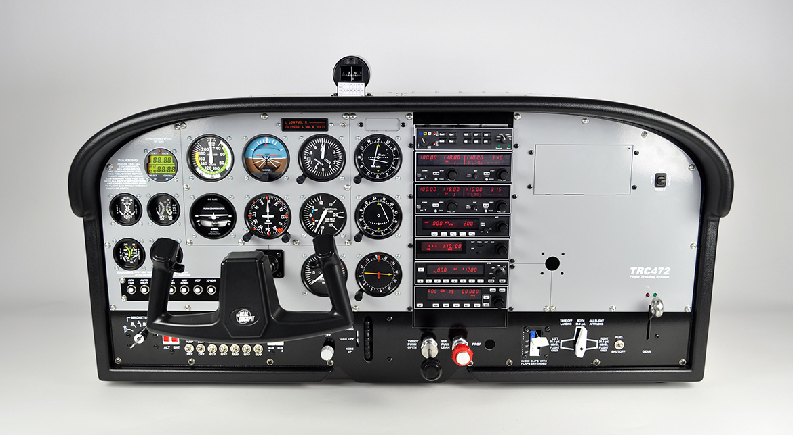

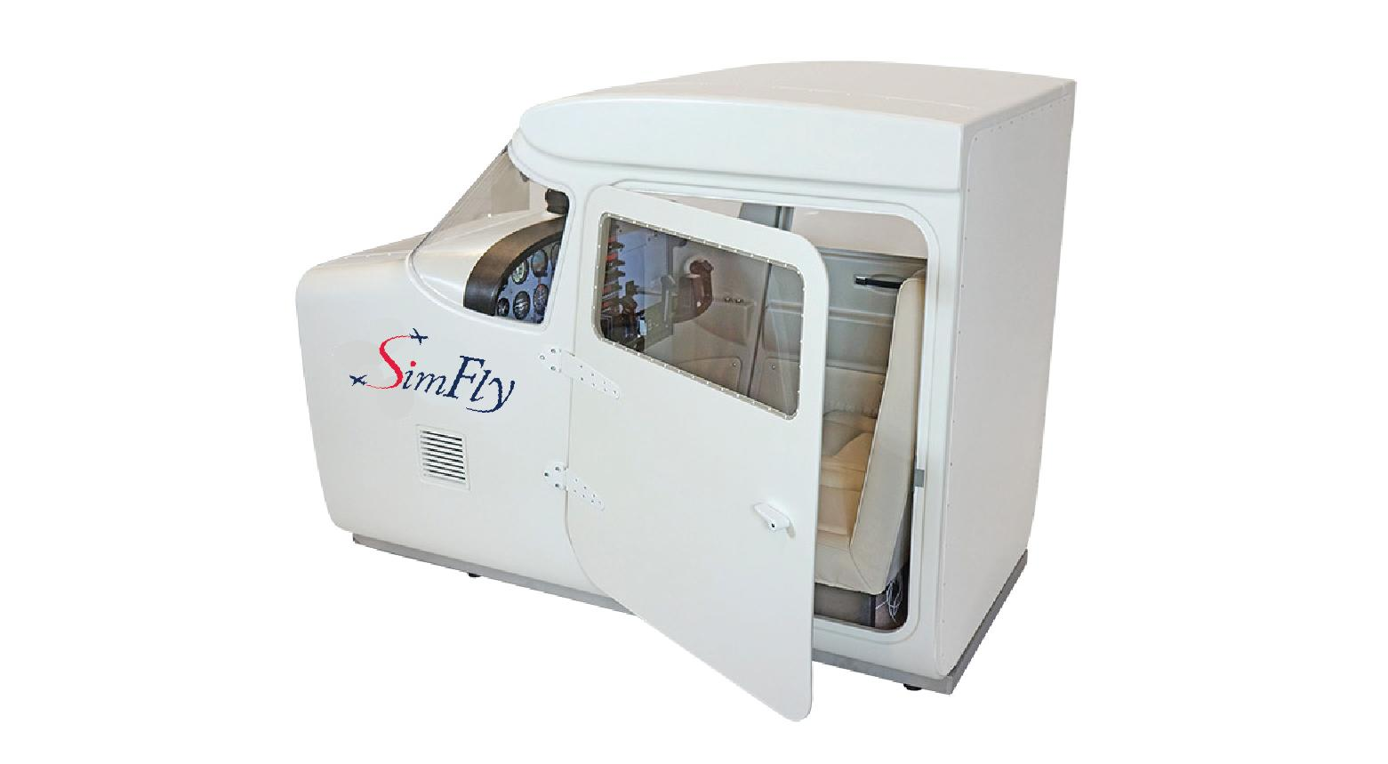
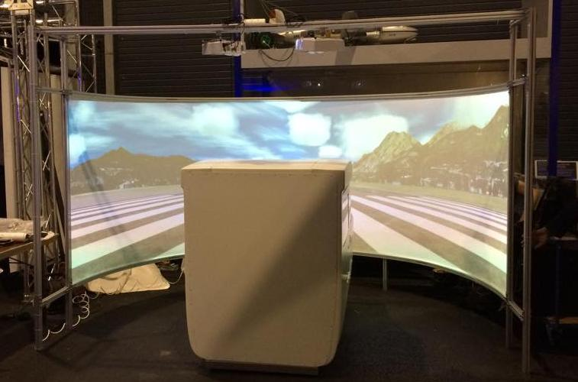

Download Colour Brochure (PDF):

SimFly C172 Flight Simulator Brochure

For the Aviation Enthusiast
The FST1100 is the ideal flight simulator to have at home. It comes as a turn key package and is narrow enough (800mm) to fit through the average size doorway and is mounted on fully castoring braked wheels which makes it easy to relocate and position into place or be moved aside when not in use. All that is needed is a dull room approximately 3metres x 3metres and a clean pale coloured wall (or optional projection screen) for the external visual projection and a powerpoint nearby.
It is a fully self contained unit, which includes all the normal aircraft controls, avionics and flight instruments. Located in the front is the external visual projector that can display an image that is equivalent to a 140 inch television screen and hidden underneath the instrument panel is the PC, keyboard and track pad.
You are then able to choose from 1000's of airports across the world and fly in all types of challenging weather in your choice of aircraft.
The controls and dynamics of the FST1100 are suitable to use as a personal instrument and / or flight trainer.
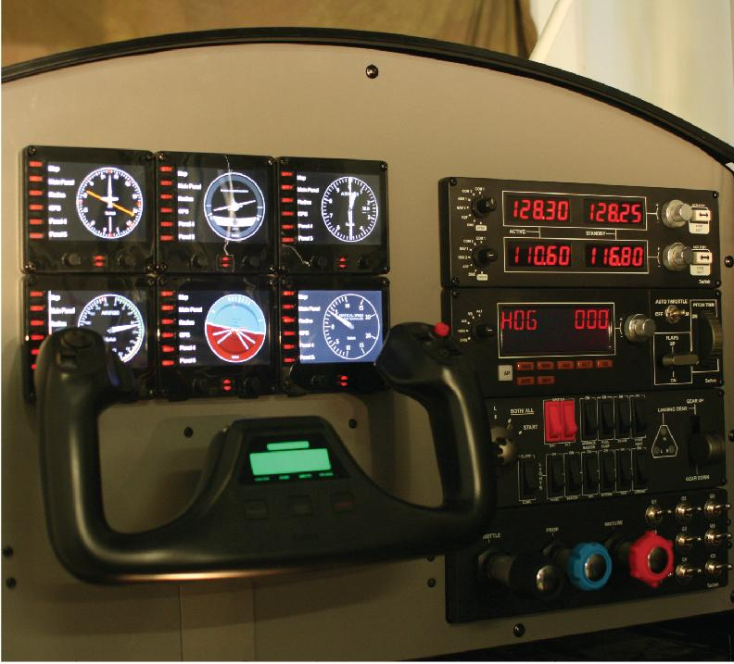
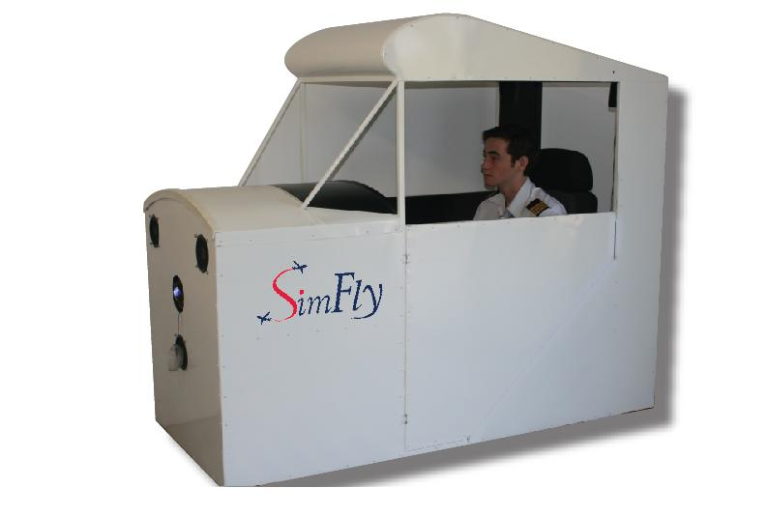
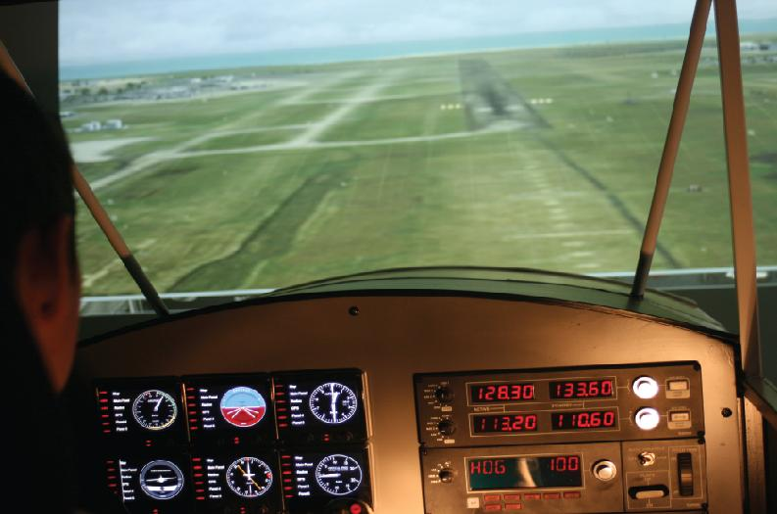

Download Colour Brochure (PDF):
SimFly FST1100 Flight Simulator Brochure

